Text Rendering
________________

Requirements
In order to render text, 2 things are necessary: some representation of a font (that is, a set of characters) and a string of text to be rendered. The latter is simply a data structure holding a representation of a character (such as an array of chars). The former can be represented in a few ways such as a series of vertices representing a glyph or a texture holding bitmap data of each pre-rendered glyph. The texture approach is probably the simplest and is thus the method which will be deployed.

Two additional classes must be implemented to support text rendering in our existing render pipeline. The first is our Font resource – an expensive object that should be re-used and not frequently created and destroyed (usually, fonts are loaded at initialisation and persist until process end). Our renderable object (Text) will hold a reference to a Font object and a string representation. See figure 1 for a visual representation of our new classes' relationships with our existing system and each other.

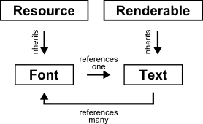
figure 1
A Font is a resource: it is expensive and so can be managed via a Resource Manager and Resource Pointers.
Text is a Renderable: it can be added to a Render Batch and has all required attributes to exist in our render pipeline.
Text holds a single reference to a Font instance; a Font holds references to many Text instances (which are referencing it).

Font Class
The Font class will manage its own texture (character bitmap) and as a result will also need to know information about each character in the texture, such as its texture coordinates and its metrics (including but not limited to kerning, vertical drop and dimensions). This information will be stored in a map data structure using the character as the key, the value will be a custom structure containing the necessary information. Whilst the Font could manage the texture at a base level (interacting directly with OpenGL) and remain relatively modular, since the Texture class is also part of the render pipeline (and also inherits from Renderable) it makes sense to instead use that to manage the texture. We can modify figure 1 to show this new relationship:

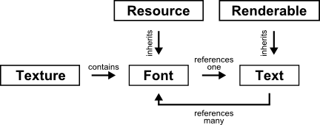
figure 2
Our Font class now depends on the Texture class (also of our render pipeline).

There are only a few functions that the Font class must perform for basic functionality. Most of these deal with the creation of the font texture: loading from a font file (like a .ttf), loading from and image file (such as a .png) and loading from memory (most likely a std::vector). The Font must also be able to return the data relating to a specific character (that is, texture coordinates and metrics) if available. Table 1 shows a prototype for our Font class, including brief descriptions of member functions and data.

Font inherits from Resource

Performs
Load from Font File
Open and parse font file from File Location and render glyphs for every character in Character Map to a texture, storing position and metrics in a map.

Load from Image File
Load image file from File Location into texture and create map storing position and metrics from Character Map.

Load from Memory
Create texture from data in Array and create map storing position and metrics from Character Map.

Return Character Data
Return the texture coordinates and metrics for a Character in the character map.

Contains
OpenGL Texture
A texture that holds all of the requested characters, packed squarely and padded.

Character Data Map
A map that holds the texture coordinates and metrics of every requested character in the texture.
table 1
The basic layout for our Font class, including brief descriptions.

There is a potential problem when it comes to creating our font via an image file or from memory and that is the lack of font metrics. There are a few possible solutions to this, all of which have a possible case which validates there existence. The first would be to also provide a font file thus allowing the metrics to be read from that. This allows us to have accurate and detailed metrics but does require that we have access to a font file that matches our image or array, which might not always be the case. The next would be to provide metrics via another file or array. We can then add these metrics directly into our map. The downside is the difficulty in managing this extra information. The final option is just to ignore the metrics and rely on naïve spacing using the width, height and padding of the character in the texture.

Talk about data struct needed
Talk about metrics availability

